Title: Crossing Horizons: A Visual Expedition through World Bank Indicators Across Nations and Years

Name: Anirudh

Student id: 22101110

Abstract:

This study explores a comprehensive analysis of international data, with a particular emphasis on the performance of chosen indicators in various nations over a prolonged duration. Using a methodical methodology, we follow each nation's path in great detail, identifying trends and identifying variations in the desired metric. Our study offers a thorough knowledge of how performance has changed over time through this deep approach, providing insights into the complex mechanisms that influence worldwide patterns. This study adds to our understanding of the complex nature of socioeconomic development by highlighting the need of context-specific assessments.

Data link

<https://data.worldbank.org/topic/climate-change>

1. Introduction

This report provides analysis and comparison-based visualization for countries. Selecting some indicators to provide a correlation among them for a specific country. This study adds to our understanding of the intricate relationship between indicators and temporal changes, highlighting the need of context-specific analyses in comprehending the intricacies of global socioeconomic growth.

1. Data Summary

The data summary aims to provide a 5-pointer summary for a database specifically for each country for all the indicators. To further explore the relations and indicators correlation with one another correlation heatmap produces some insights below.

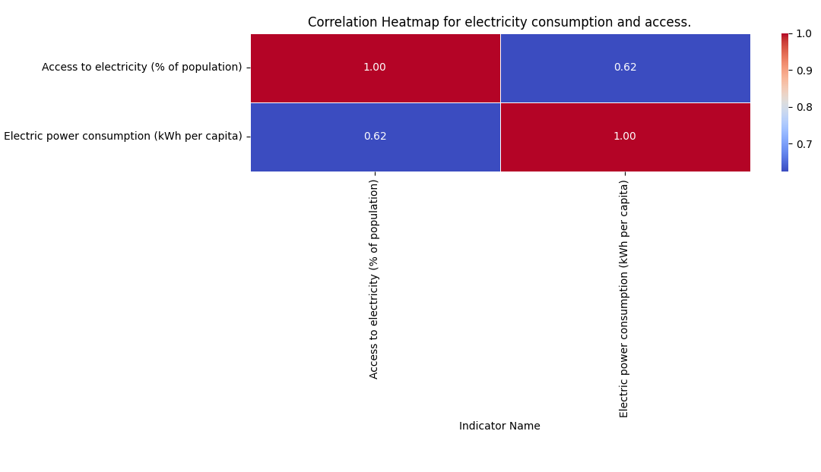This heatmap provides correlation between electricity consumption and access to electricity specifically for Pakistan. Such correlation between indicators is useful in analyzing the country power consumption and access to the basic needs of electricity for all the citizens.

# Irrigated land comparison - Line Chart

Line chart Comparison to show the irrigated area of land for agriculture Oman has the vast irrigated land of agriculture after 2020. Nepal agriculture system got a rapid decline after 2010. Agriculture is considered to be an important part of the country economy and countries around the world can get enough insights from such comparison which are specifically for over the years.

1. 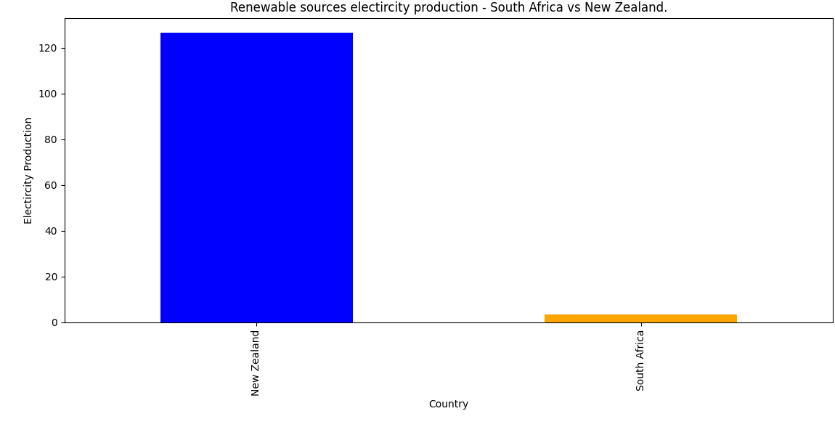Bar Chart – Electricity Production Comparison

A bar chart in this comparison study clearly shows the divergent paths of renewable energy development in New Zealand and South Africa. The graphic highlights South Africa's varied energy mix and the country's continuous transition to renewable energy, with New Zealand emerging as a leader in the use of sustainable energy. The two countries' distinct energy environments are reflected in the considerable discrepancies in the amount and sources of renewable power generated.

# Primary School Completion

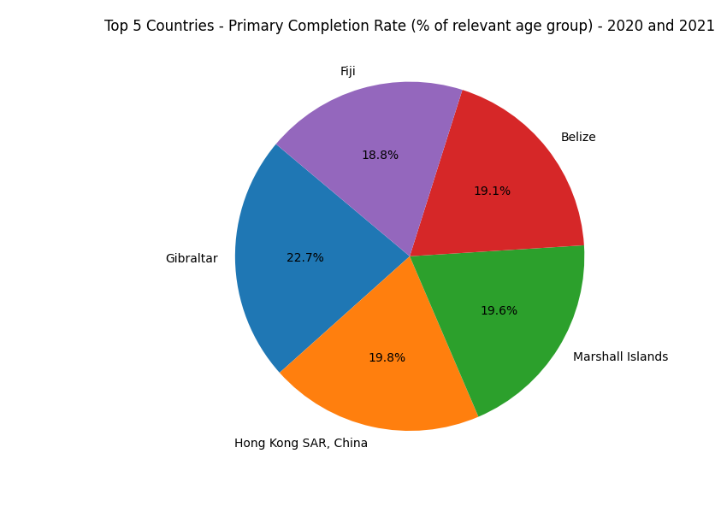A comparison was made to provide proportion of countries where primary completion has most among the countries present in the dataset.

1. 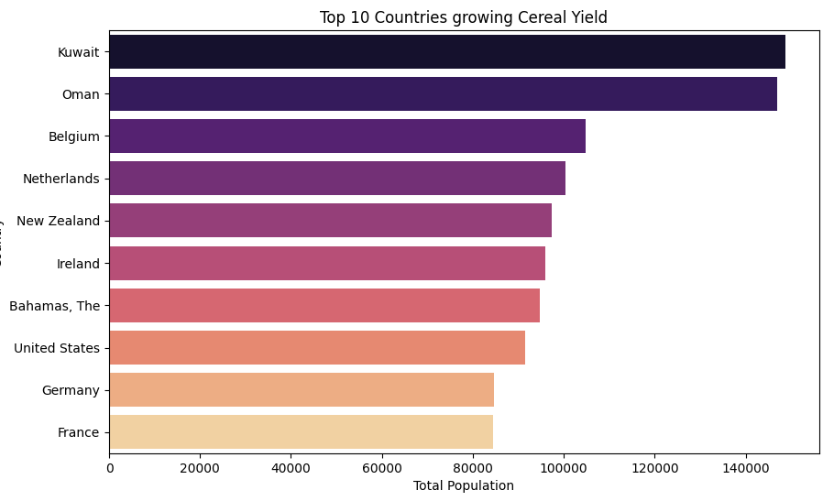Cereal Yield Comparison

Top 10 countries shown in the vertical bar graph, this represents the countries cereal yield growth, Kuwait tops the chart while France is on the last number 10.